CS 305 Project One Template

Document Revision History

Version | Date | Author | Comments
1.0 | 3/20/26 | Kaseem Wright

Client



Instructions
Submit this completed vulnerability assessment report. Replace the bracketed text with the relevant information. In this report, identify your security vulnerability findings and recommend the next steps to remedy the issues you have found.

- Respond to the five steps outlined below and include your findings.
- Respond using your own words. You may also include images or supporting materials. If you include them, make certain to insert them in the relevant locations in the document.
- Refer to the Project One Guidelines and Rubric for more detailed instructions about each section of the template.

Developer
Kaseem Wright

1. Interpreting Client Needs
Determine your client’s needs and potential threats and attacks associated with the company’s application and software security requirements. Consider the following questions regarding how companies protect against external threats based on the scenario information:

- What is the value of secure communications to the company? The value of secure communications is that it protects sensitive financial information such as investment, retirement, insurance and personal info. It also prevents data breaches, identity theft and against fraud. Ensuring data integrity builds customer trust which at the same time builds the company’s reputation. And is supporting compliance with financial and data protection guidelines.
- Are there any international transactions that the company produces? Yes, there are international transactions that the company produces, because Artemis Financial is serving clients around the globe which involves data exchanging cross-border. So, it requires secure communication channels such as HTTPS and encryptions. There are different regional data protection expectations. And in modern times there is an increased exposure to cyber threats around the world.
- Are there governmental restrictions on secure communications to consider? Yes, there are governmental restrictions to consider. They must comply with data protection and financial regulations which can be different based on the region. Privacy laws can dictate how the company can store the data, how it’s processed and transmitted. They must use secure communication standards such as HTTPS/TLS in the financial systems. And encryption might be required to transmit sensitive financial information.
- What external threats might be present now and in the immediate future? The external attacks the are present now and soon are injection attacks, which are malicious input through API requests, Denial-of-service (DOS) attacks on the API endpoints, vulnerable third-party dependencies being exploited, data interception from the data not being encrypted, and unauthorized access because there wasn’t a proper authentication/authorization. And a few future threats could be zero-day vulnerabilities, bot attacks that are automated, and evolving malware.
- What modernization requirements must be considered, such as the role of open-source libraries and evolving web application technologies? For open-source libraries, the use of Maven dependencies to see the supply chain risks, having more frequent dependency-checks and just keeping libraries up to date so the security of the libraries is up to date. And for evolving web application technologies, the need for scalable and secure API design, making HTTPS/TLS for secure communication standard, RESTful APIs seeing more exposure to internet-based attacks and implementing secure coding practices.

2. Areas of Security
Refer to the vulnerability assessment process flow diagram. Identify which areas of security apply to Artemis Financial’s software application. Justify your reasoning for why each area is relevant to the software application.

After referring to the vulnerability assessment process flow diagram, the areas of security that apply to Artemis Financial’s software application are authentication and access control, input validation, cryptography/secure communication, dependency/supply-chain security, error handling and information disclosure and API security/secure coding practices. For authentication and access control, the REST endpoints are exposed, and it also handles financial data, so authentication and access control is very important. Only authorized users should be able to access financial data or use sensitive operations. Next for input validation, its relevant because the API is accepting users through the request parameters OWASP states untrusted input must be validated to lower risks like injection, abuse of business logic and malformed data processing. The financial services application requires strong protection for the data that’s in transit, Artemis Financial wants secure communication for their clients and partners so using Spring Boot to support SSL/TLS configuration. Dependency/Supply-Chain Security is valid because the application uses Maven and open-source libraries, and dependency checks are useful because third-party components can have vulnerabilities that are published and newer stacks use external packages heavily. For error handling and information disclosure, it will be best that the application avoids exposing internal details through its responses, overly detailed outputs and stack traces. And that is because the application is directly reflected in the input it is receiving into the output, which can cause a risk in unintended disclosure of the information or misuse if the endpoints are similar. And for that reason, OWASP has proactive controls that pairs input validation with proper exception handling. And for API Security/Secure Coding Practices is relevant to the project because the REST APIs are exposed to external callers, so it needs the endpoints to be more secure, the defaults need to be secure and a more careful coding practice. Artemis Financial is modernizing a web API, that means that the security of the API is very important.

3. Manual Review
Continue working through the vulnerability assessment process flow diagram. Identify all vulnerabilities in the code base by manually inspecting the code.

GreetingController.java - Unvalidated user input
The /greeting endpoint is accepting a name parameter from the request without validating it first, which can lead to malicious input and causing an injection style attack.
GreetingController.java - Reflected input in response
For the greetingController.java the controller is using String.format(template, name)to put the user input into the response. And if expanded into a browser based application this can cause unsafe output issues.
GreetingController.java and CRUDController.java - No authentication or authorization
The controllers for both greeting and CRUD are exposing the API endpoints without any authentication or authorization controls, and they should be accessible without user verification.
CRUDController.java - Unvalidated request parameter
For the CRUDController.java, the /read endpoint is accepting the business_name parameter but isn’t validating it before it uses it. And accepting raw input without validating it first isn’t secure.
CRUDController.java - Direct exposure of internal object data
The CRUDController.java is returning doc.toString() back to the client inside of the CRUD object. And returning a raw object output can expose internal data that wasn’t meant to be seen.
CRUD.java - No input validation
With the CRUD class constructors is accepting string inputs without validating them first. And since these values are possibly coming from the API requests and malicious/invalid data can be stored and used in other parts of the system later.
Customer.java - Exposure of sensitive financial data
For the customer.java, showInfo() method is returning sensitive customer information. And in financial systems, account identifiers should never be exposed and is a top priority when it comes to security.
Customer.java - No validation in deposit method
For the customer.java, the deposit (int a) method is adding whatever values that are passed through which includes negative values. So, the user and reduce the account balance by passing a negative amount.

4. Static Testing
Run a dependency check on Artemis Financial’s software application to identify all security vulnerabilities in the code. Record the output from the dependency-check report. Include the following items:

- The names or vulnerability codes of the known vulnerabilities
- A brief description and recommended solutions provided by the dependency-check report
- Any attribution that documents how this vulnerability has been identified or documented previously

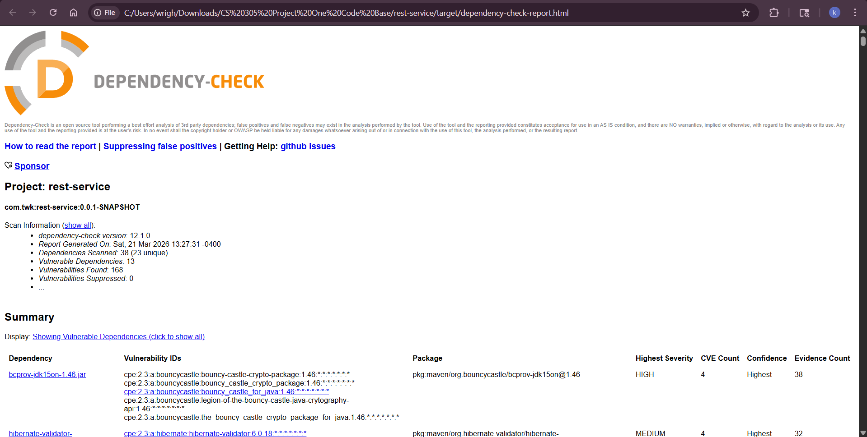
Tool used: OWASP Dependency-check
Project: rest-service
Dependencies scanned: 38 (23 unique)
Vulnerable Dependencies: 13
Total Vulnerabilities Found: 168
Key Vulnerabilities identified:
Bouncy Castle Cryptography Library
Dependency: bcprov-jdk15on-1.46.jar
Severity: HIGH
CVE Count: 4
This version of the bouncy castle cryptography library contains vulnerabilities that are known which can allow for exploitation in the encryption processes. And is recommended to upgrade to a newer version of the library that is more secure. Attribution: identified by OWASP dependency check with references to known CVEs (NVD/CVE)
Hibernate validator
Dependency: hibernate-validator-6.0.18
Severity: MEDIUM
CVE Count: 4
The dependency has known vulnerability issues relating to handling input validation so weak validation can result in malicious/improper data to go through the application. A recommended solution is to upgrade to the newest stable version of Hibernate validator. Attribution: identified using the OWASP dependency check by the publicly documented vulnerabilities.

5. Mitigation Plan
Interpret the results from the manual review and static testing report. Then identify the steps to mitigate the identified security vulnerabilities for Artemis Financial’s software application.

Add authentication and authorization by integrating Spring security so that the API endpoints need authenticated access. Valid all user input by using server-side validation for all the request parameters, and put rules such as length limits, expected character sets, business rules and having it rejected malicious inputs before it makes it too logic. Going to avoid reflecting raw input directly in responses by double checking user-supplied values before using them in the logic and using safe output pattern so it echoes everything the user is entering. Then going to enable HTTPS/TLS on all communications by requiring it for all clients, so it protects data while it’s in transit. Patching or replacing vulnerable dependencies, looking over the CVE that’s reported by the dependency check and either updating the affected libraries and or removing the ones that aren’t being used in the application. Next, I am going to improve exception handling and error responses by not exposing internal class names, framework details or traces of the stack. And only sending out basic messages to user while logging the detailed messages internally. Secure the SDLC with regular dependency checks during the building phase and before releasing the product, making it part of the development process instead of a one-time event. And lastly, we will conduct ongoing code review and testing security by manually doing code review, dependency checks and API security checks before the product reaches the rollout stage.

